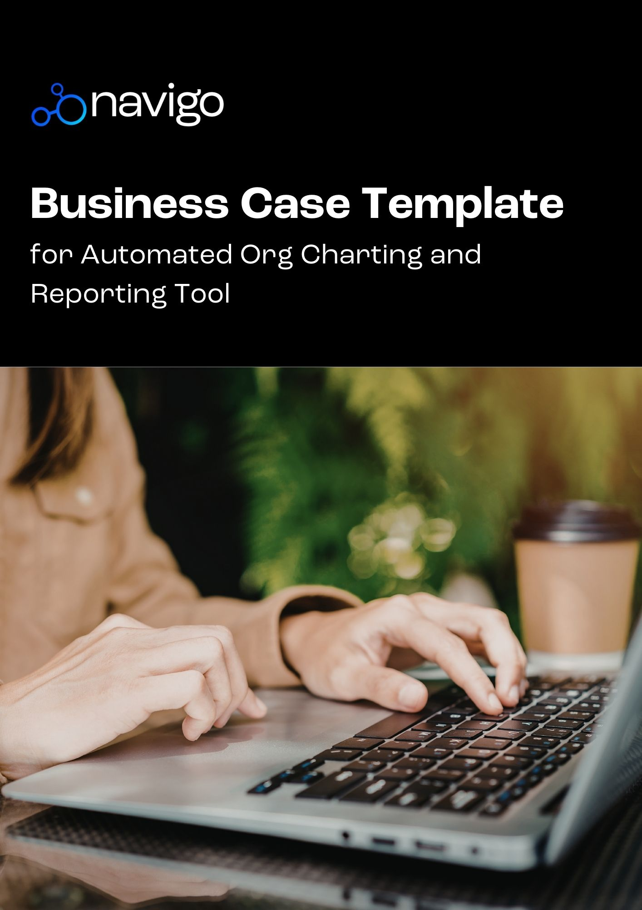

Business Case for Automated Org Charting and Reporting Tool

<organisation name>
<organisation Address>

Version 1.0

DD/MM/YYYY

VERSION HISTORY
VERSION | APPROVED BY | REVISION DATE | DESCRIPTION OF CHANGE | AUTHOR

PREPARED BY |  | TITLE |  | DATE
APPROVED BY |  | TITLE |  | DATE

Business Case Table of Contents
Executive Summary 1
Project Definition 1
Background 1
Problem Statement 2
Project Objectives 2
Options Analysis 3
Evaluation of options 3
Option A 3
Option B 3
Recommended option 4
Recommended option vs Visio/ PowerPoint 4
Project Scope 5
Cost - Benefit Analysis 5
Benefits 5
Risks/costs 5
Project Stages and Duration 6
Financial Analysis 6
Budget breakdown 6
Project Management 7
Governance 7
Quality management 7
Progress monitoring 7
Project Endorsement 8
Appendices 8
Appendix A 8
Appendix B 8
Appendix C 8

Executive Summary
Briefly introduce the project: what it is and what needs it addresses. Summarise what is required to successfully execute the project. This should take a reader about five minutes to read and should provide them with all the information they need to have a solid overview of the project and its requirements.
The key objective of this project is to create org charts that support workforce planning and restructures as well as provide greater visibility of organisational structures across the organisation. The solution will be visible to all employees, however access to specific data and functionalities will be determined based on roles and requirements. An organisation chart solution will provide the following benefits:
- Enable improved workforce planning by providing clarity on staffing levels, including easily identifiable vacant positions, and organisation structures
- Improve communication across the organisation by showing the relationship between positions and providing insight into the org hierarchy
- Reduce manual workload for HR administrators and immediate access to senior HR Managers by providing real-time, configurable and easily viewable charts
- Support diversity and inclusion initiatives by highlighting gender split and ratios across the organisation.
- Potential to use org charts for strategic decision-making and more effective staff management (e.g. use of leave balances, span of control, skills mapping etc.)

Project Definition
Project Name | Project Sponsor | Project Manager

Background
Describe the need for this proposed project and the possible benefits of implementing it.
Example -
There is currently no formal organisational charting or reporting activity taking place within the organisation. Different departments are adopting ad hoc, manual charting and reporting procedures using different tools such as Visio (which is primarily a diagramming/flow chart tool), Excel and PowerPoint. There is no dedicated org charting or reporting tool which leads to time-consuming manual tasks and sometimes inaccurate reporting.
When org charts are created, they’re typically generated from differing or siloed data sets instead of a single source of truth. This presents significant challenges when making comparison across business units and assessing the impact of workforce changes.

Problem Statement
Clearly summarise the problem that the project is aiming to address. Mention aspects such as - where is the ‘pain’, who is facing it; and, if necessary, why your department should be doing something about this, what are the likely consequences of not addressing the problem etc.
- Inability to produce a timely, accurate report or visualisation of the organisation
- No accurate or up to date visualisation of the current workforce resulting in a risk of incorrect FTE, salary and position details being reported to management
- Different departments spending time creating their own organisational structure or reports using different tools

Project Objectives
Describe what questions about the project the business case will resolve.
To implement an automated org charting and reporting tool that will –
- Improve visibility of the workforce
- Ensure employee data is being reported accurately using up to date information
- Save each department, especially HR, time in creating charts and producing reports for management

Options Analysis

Evaluation of options
Provide an overview of options in addition to the proposed solution. For each option, the following information should be provided:
- Benefits and disadvantages
- Costs: Include total costs for all deliverables, risk buffers, and project management activities as well as all other direct and indirect costs.
- Risks: Include risks such as loss of customer demand, equipment and facility issues, lack of insurance bonding, regulatory changes, and any other related risks.

Option A
Option description | Benefits | Disadvantages | Costs | Risks
Navigo’s org charting solution | Enhanced user experience  Gain instant access to current business focused HR analytics  Create customised charts including corporate/employee directory, management dashboards, workforce modelling and succession planning  Review organisation chart by individual business unit or the whole faculty/portfolio  Configure the data to show position and/or employee data  Create an advanced search and filter based on department, business unit, name and position  Identify vacant positions  Org charts can be exported to excel, PowerPoint, pdf and will save time in workforce planning administration as charts update automatically |  | Variable based on organisation size | Security/access to sensitive info

Option B
Option description | Benefits | Disadvantages | Costs | Risks

Recommended option
Describe the preferred option derived from the previous analysis.
Navigo’s org charting solution is the preferred choice for this project as it meets most of our requirements – the table below provides a summary of the proposed solution vs other tools such as Visio and PowerPoint.

Recommended option vs Visio/ PowerPoint
Features | Navigo’s org charting solution | Visio | PowerPoint
Basic org chart creation
Create different types of automated org charts including leave liability, gender, generation, succession planning, restructuring & many more
Role based security
Manual handling of data required
Seamless integration with your existing HRIS or payroll system
Corporate directory
Scalable org charts which can expand to meet your organisation’s growing needs
Planning and modeling tools to allow users to create and share workforce plans, track changes and synchronise plans
Sophisticated security to ensure authorised access to information
Conditional formatting & customised calculations
Intuitive drag & drop interface

Project Scope
Inform the primary decision makers the scope of this project including what’s in scope and what’s out of scope.
In Scope | Description
Design and Content | A review of current data and charts used within the organisation.
Change Management | Engagement with all relevant stakeholders
Project Management | Oversee the setup, implementation, design and configuration of customised charts.
Training | Provide training to admin and users within the organisation.

Out of Scope | Description
Additional training and chart consultation | Additional Navigo consulting and training to build customised features not included in the implementation plan
Development of any workflow tools | Not included in the implementation plan

Cost - Benefit Analysis

Benefits
Description | Owner | Current state | Future state | Realisation date | Measure

Risks/costs
Major risks | Strategy | Risk owner | Cost | Risk grade
Total

Grade Rating | L | 1
Grade Rating | M | 2
Grade Rating | H | 3
Grade Rating | VH | 4

Project Stages and Duration
Describe how the project will be executed. Include the following:
- High-level project phases
- Target completion dates
- Cost to implement the plan
- Personnel and expertise required – what are the deliverables for each of the phases

Phase | Estimated completion date | Cost | Expertise required/Deliverables
Introduction | 1 week |  | Project manager/project team to provide necessary documents and approve access to Navigo team
Discovery | 2 weeks |  | Discovery sessions with representatives from HRD and other business areas if required
Planning | 2 weeks |  | Set up and configuration. Configure charts and security and required modules within the software
Testing | 1 week |  | User Acceptance Testing and provide feedback
Delivery | 2 weeks |  | Deliver the training courses on site
Support | Ongoing |  | Navigo team and primary user of the org charting software within the organisation

Financial Analysis

Budget breakdown
Description | Cost
Item 1
Item 2
Item 3
Subtotal
Contingency (x%)
Project budget

Project Management

Governance
List the responsible parties and their contact information. For e.g.
- Project manager is responsible for managing project implementation.
- Project sponsor is accountable for ensuring the project is completed.
You may also describe your project team, review teams and quality consultants.
Party responsible | Role | Contact information

Quality management
Describe the quality management approach, i.e. approved methodologies and standards, change and problem management and the review and acceptance process.

Progress monitoring
Mention how you will monitor and compare actual achievements against your baseline plan.

Project Endorsement
Mention the key stakeholders who have endorsed this project
Validator | Endorsed Area | Validated by
Risk and Compliance | Strategic risks or those unique to the project | Name of person

Appendices

Appendix A

Appendix B

Appendix C

